Seminar
A CHANGED WORLD
Fostering Resilience in the New Global Order

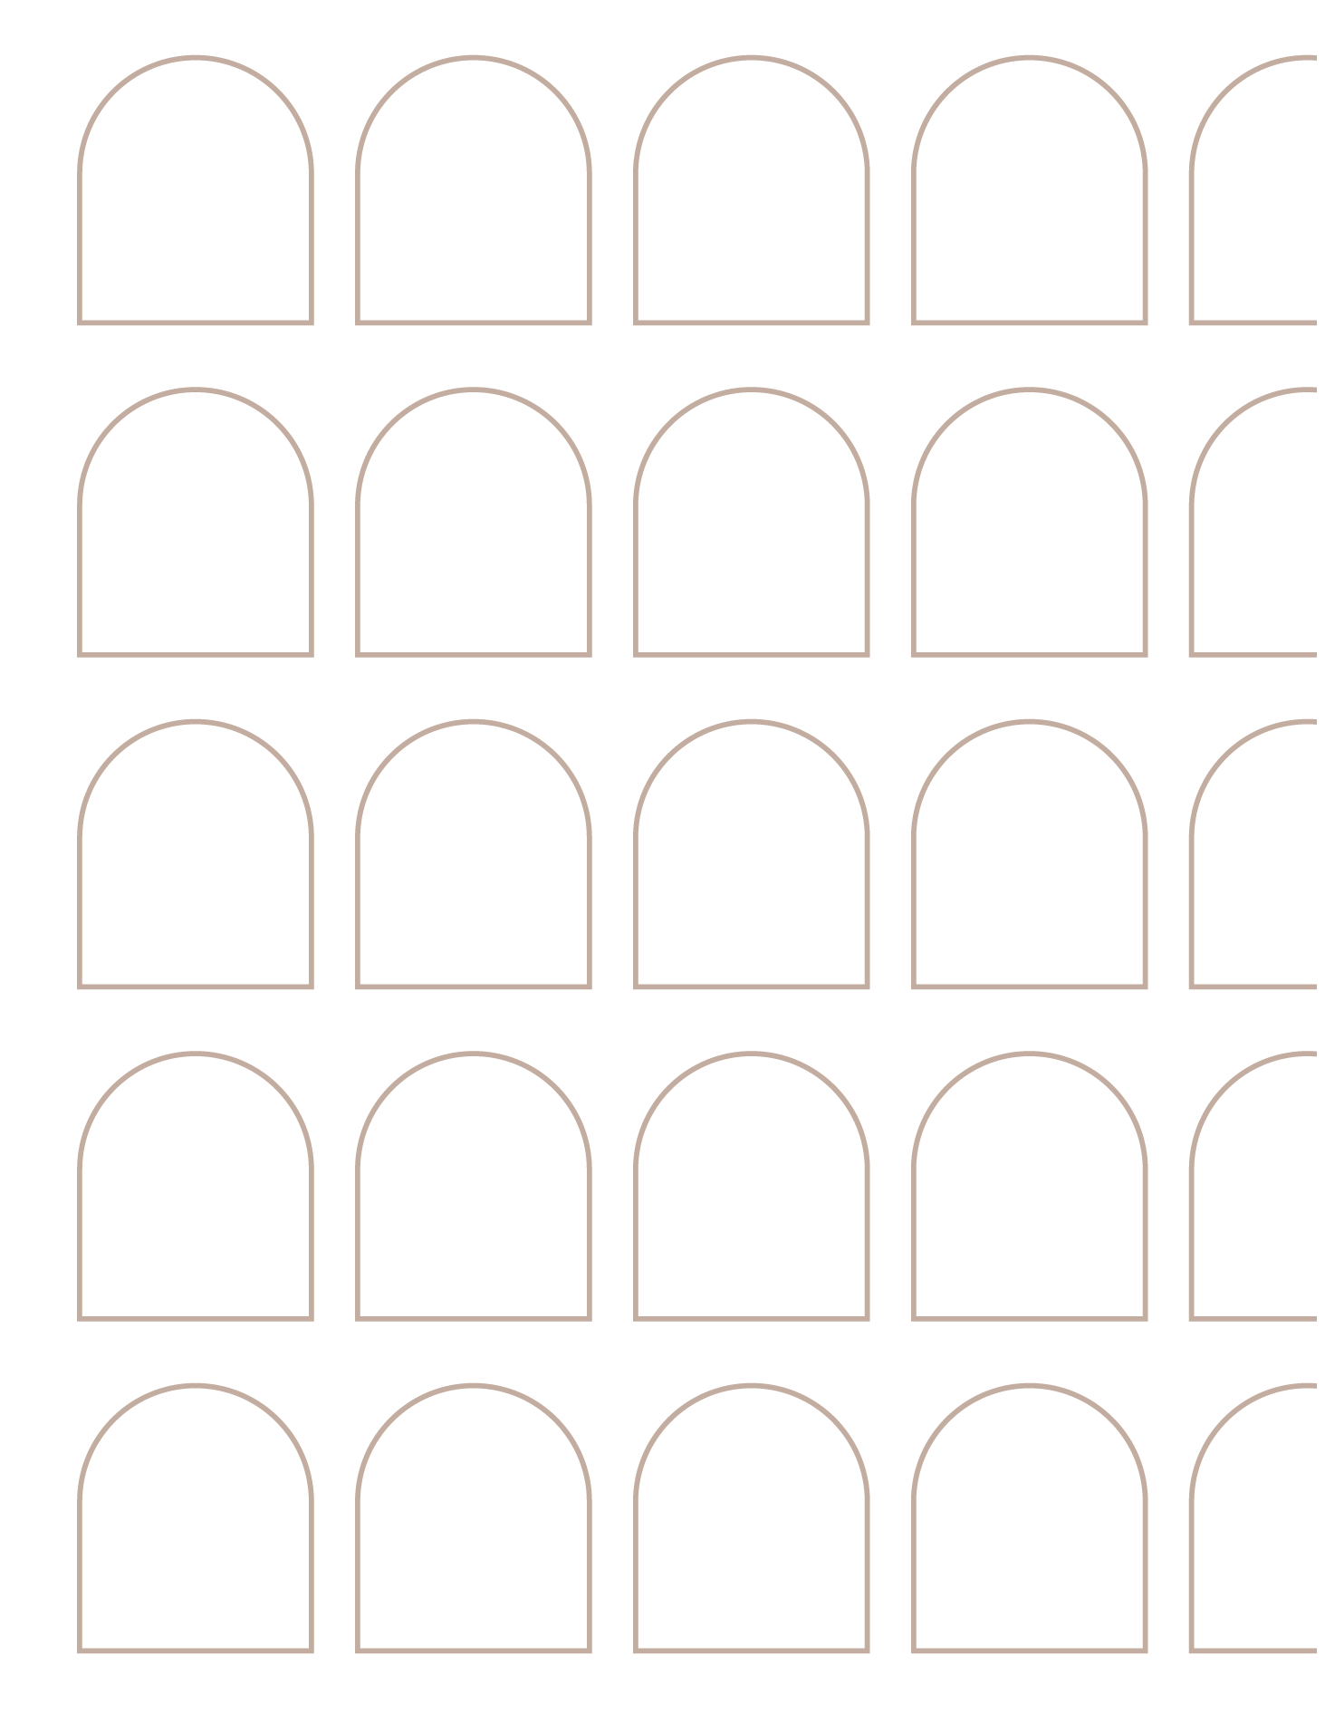
Monday, 07 April 2025

Overview
Organisers 2
Event information 2
Logistical details 2
Contacts 2
Programme 3
Speakers and LoP 4

Organisers
Elisabetta Fonck | European Parliament Former Members Association
Johanna Litzen | Florence School of Transnational Governance
Linda Rovelli | Florence School of Transnational Governance

Event information
High-Level Seminar: A Changed World. Fostering Resilience in the New Global Order
The global order is undergoing significant transformations, marked by shifting power dynamics, evolving trade relationships, and new challenges to governance. This high-level conference, hosted by the Florence School of Transnational Governance (EUI) and organized jointly with European Parliament Former Members Association (EP_FMA), will bring together former policymakers from the EP_FMA and the Canadian Association of Former Parliamentarians (CAFP), scholars, and experts to critically examine these developments and their implications.
Discussions will focus on the structural changes in international relations, the resilience of political and economic institutions, and the future of global governance. By engaging former policymakers from both sides of the Atlantic with diverse perspectives, the conference aims to provide a deeper understanding of the mechanisms shaping the contemporary world and explore pathways for stability and cooperation.

Logistical details
In-person participation:
Venue: Palazzo Buontalenti, Via Cavour 65, 50129 (Florence, Italy)
BTC534 Anfiteatro
Online participation:
https://eui-eu.zoom.us/j/97976477143
webinar ID: 979 7647 7143

Contacts
Johanna Litzen
Email: johanna.litzen@eui.eu
Phone: +39 331 6349197

Programme

Monday, 07 April 2025

10.00 – 10.30 |  | Arrival and brief Tour of Palazzo Buontalenti
10.40 – 11.00 |  | Welcome Coffee
11.00 – 11.20 |  | Session 1: The New World Order
Introductory remarks by:
Marco del Panta | Secretary General European University Institute (EUI)
Monica Baldi | Vice President European Parliament Former Members Association (EP_FMA)
Leo Duguay | President of the Canadian Association of Former Parliamentarians (CAFP)
Moderator: Fabrizio Tassinari | Executive Director School of Transnational Governance
11.20 – 11.30  11.30 – 11.40  11.40 – 11.50 |  | Trine Flockhart | Florence School of Transnational Governance, EUI  Peggy Nash | CAFP Canadian Member  Sir Graham Watson | EP_FMA British Member
11.50 – 12:00 |  | Q&A with audience
 |  | Session 2: Global Trade and Tariffs
12.00 – 12.10  12.10 – 12.20  12.20 – 12.30 |  | Arancha González | Paris School of International Affairs, Science Po  The Honourable Karen Redman | CAFP Canadian Member  Danuta Hübner | EP_FMA Polish Member
12.30 – 12.45 |  | Q&A with audience
12.45 – 13.00 | Concluding remarks  Kim Campbell | Former Prime Minister of Canada (TBC)  Enrique Baròn Crespo | Former President of the European Parliament & EP_FMA

SpeaKERS
Monica Baldi
European Parliament Former Members Association
Vice President
Enrique Baròn Crespo
European Parliament
Former President of the European Parliament & EP_FMA

Kim Campbell
Former Prime Minister of Canada (TBC)

Marco del Panta
European University Institute
Secretary General
Leo Duguay
Canadian Association of Former Parliamentarians
President of the Delegation
Trine Flockhart
Florence School of Transnational Governance, EUI
Chair in Security Studies
Arancha González
Paris School of International Affairs, Sciences Po
Dean of the Paris School of International Affairs, Part-time professor at Florence School of Transnational Governance, EUI
Danuta Hübner
European Parliament
EP_FMA Polish Member
Peggy Nash
CAFP
Canadian member

Karen Redman
CAFP
Canadian member
Giorgio Silli
MAECI
Undersecretary of State for Foreign Affairs and International Cooperation of Italy
Fabrizio Tassinari
School of Transnational Governance
Executive Director
Sir Graham Watson
European Parliament
EP_FMA British Member

LIST OF PARTICIPANTS CAFP delegation
The Honourable Sue Barnes | Former MP
Cecilia Kutas Chisu | PhD, Associate Professor Emerita, U of T, Associate Member
Maj (ret’d) Corneliu Chisu | CD, P. Eng., Former MP
The Honourable Dennis Dawson | Senator
Dorothy Dobbie | C.M., Former MP
Leo Duguay | Leader of the Delegation and CAFP President Emeritus
Charlette Duguay | Associate Member
Clement Joly | FCPA, Associate Member
Anne Laberge | Associate Member
The Honourable Paul Harold Macklin  Joan Macklin | Former MP  Associate Member
Ms Peggy Nash  Osvaldo Núñez  Zaida Macias Nuñez  The Honourable Karen Redman  Warren Redman  Marilyne White | Former MP, C.M., MA  Former MP  Associate Member  Former MP  Associate Member  Guest (travelling with Peggy Nash)

